**21.25 Step 25**

When the system reboots, the /etc/fstab file will be used to mount filesystems automatically. However, you *don't* want to reboot the system since any error in this file could cause the boot process to fail completely. To test the new entry in this file, unmount the /data filesystem and remount it by only specifying the mount point:

umount /data

root@ubuntu:~# umount /data

mount /data

mount

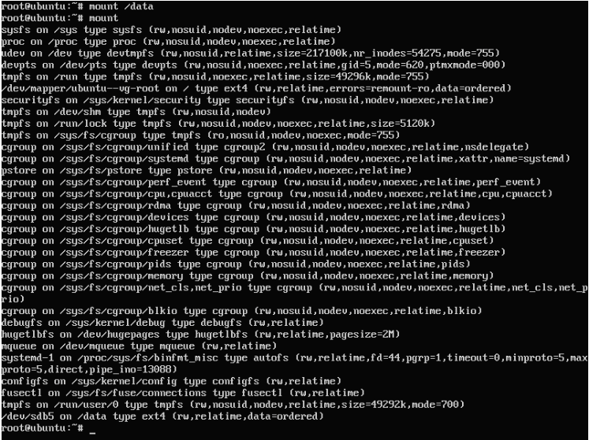

When you only specify the mount point argument when executing the mount command, the command looks at the /etc/fstab file for the rest of the information (the partition to mount and the mount options).

If you made a mistake in the new entry in the /etc/fstab file, you might get an error like the following:

root@ubuntu:~# mount /data

mount: can't find /data in /etc/fstab or /etc/mtab

If this happens, look at the /etc/fstab file, correct the error, and try to mount again.